**CLOUD COMPUTING ASSIGNMENT -02**

|  |  |  |
| --- | --- | --- |
| NAME: SAHANA RAO | SRN: PES1UG20CS588 | SECTION: J |

**TASK 1:**

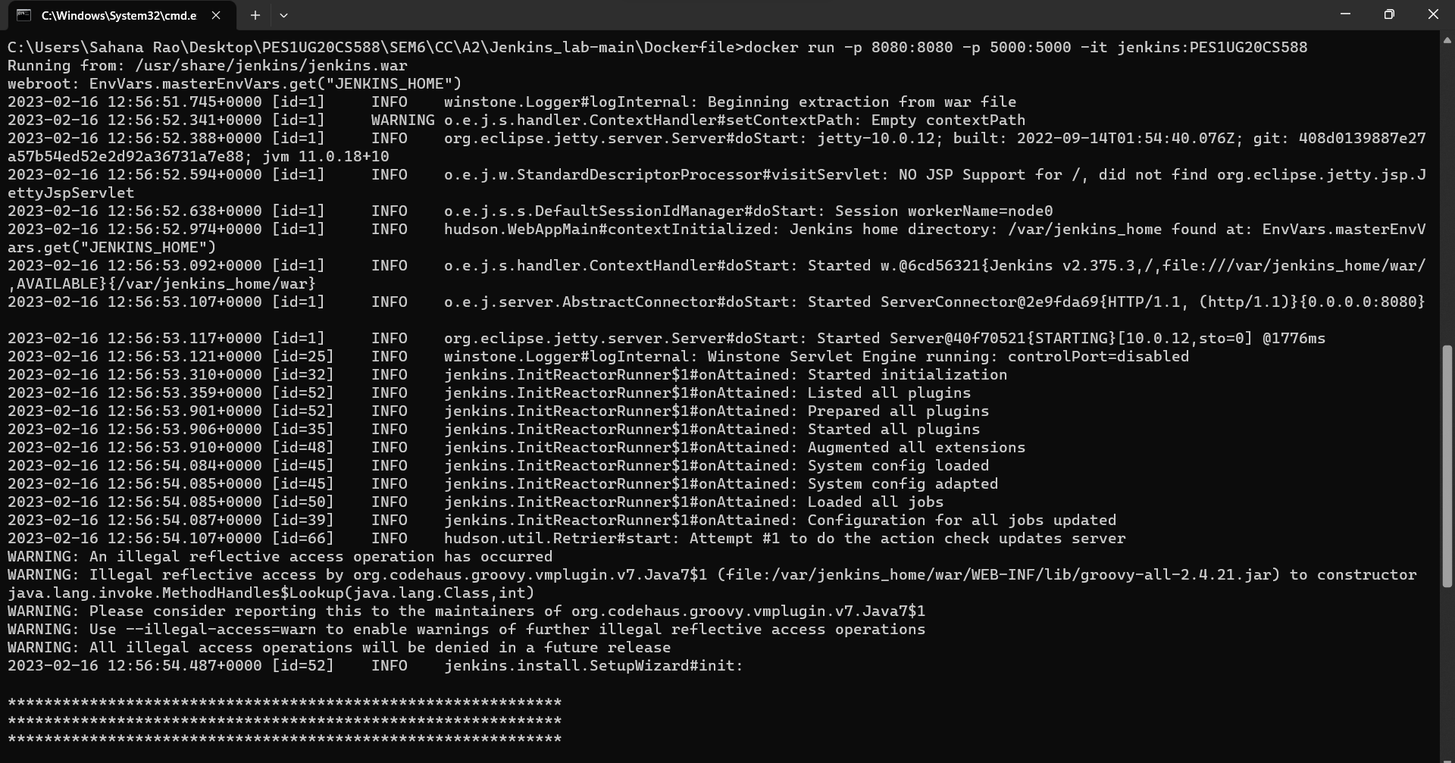

**TASK 2:**

1)Console output

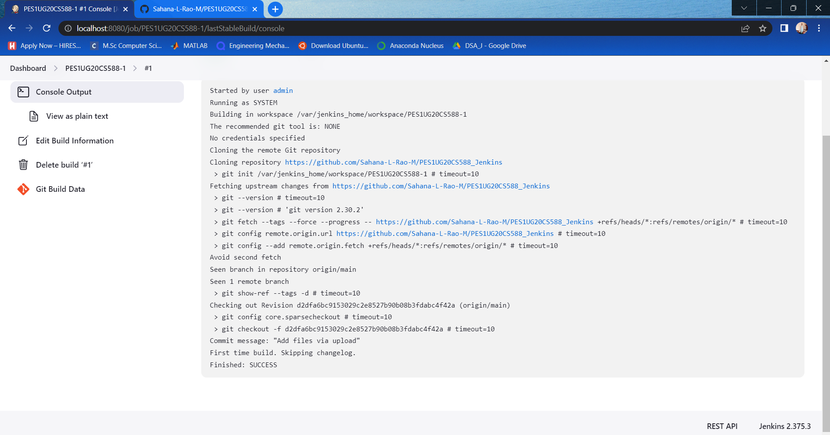

2) Stable state of the task

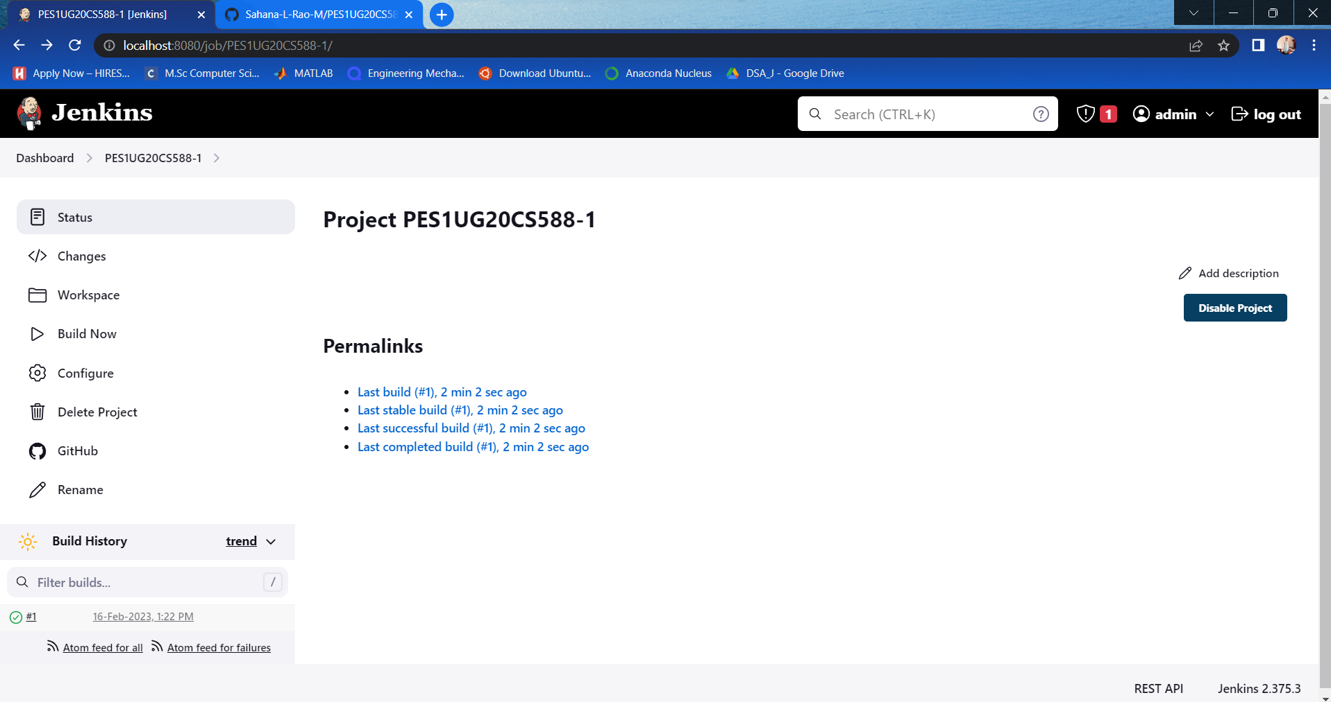

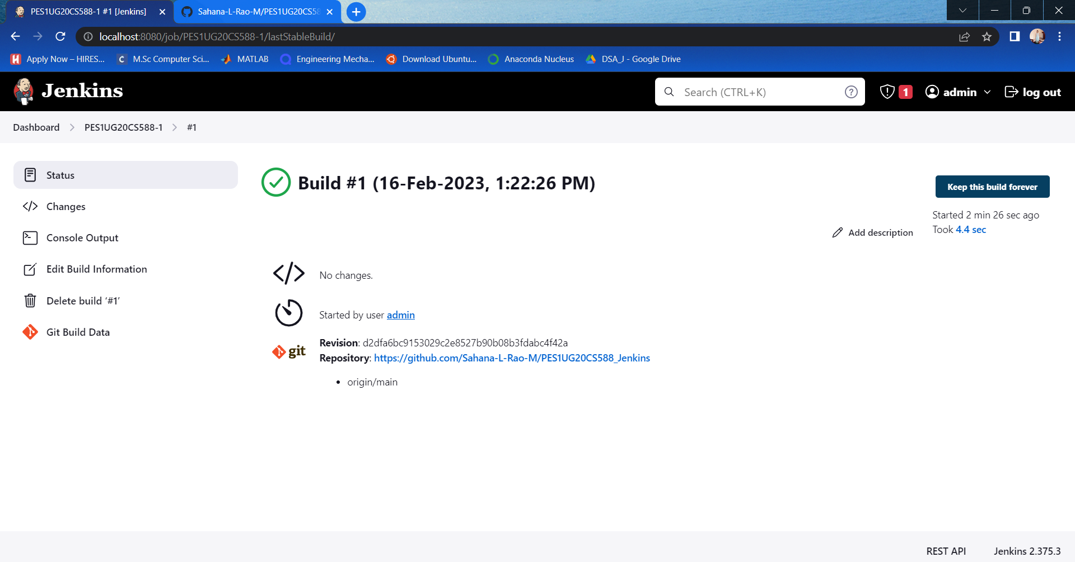

**TASK 3**

1)Console output of second job

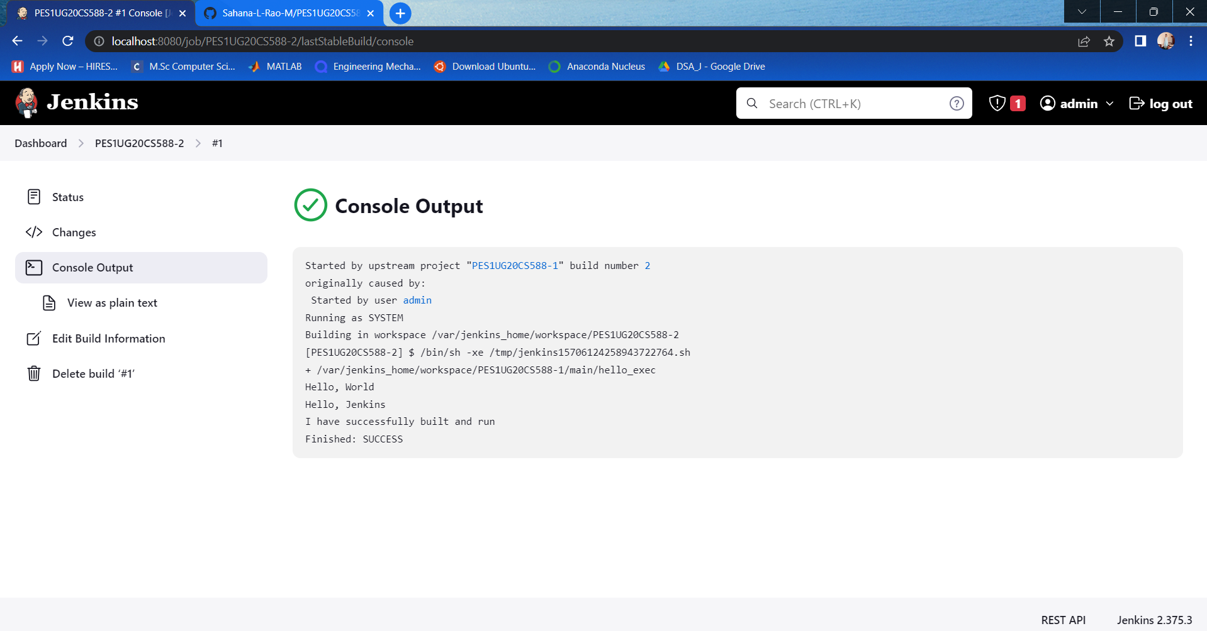

2) Status page of first job

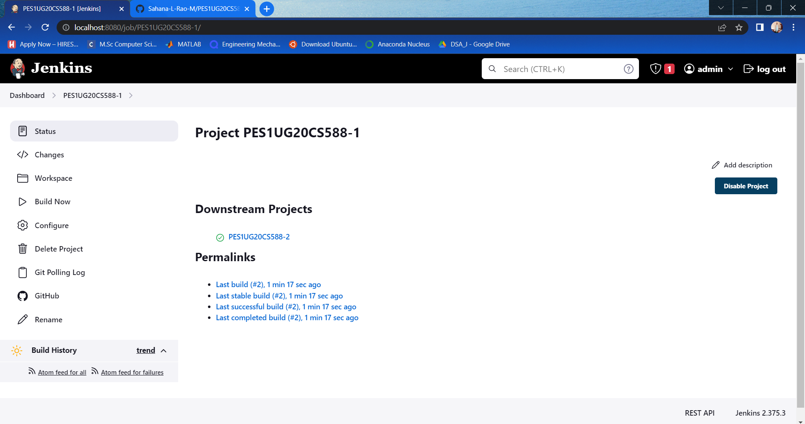

3)Build history of Jenkins

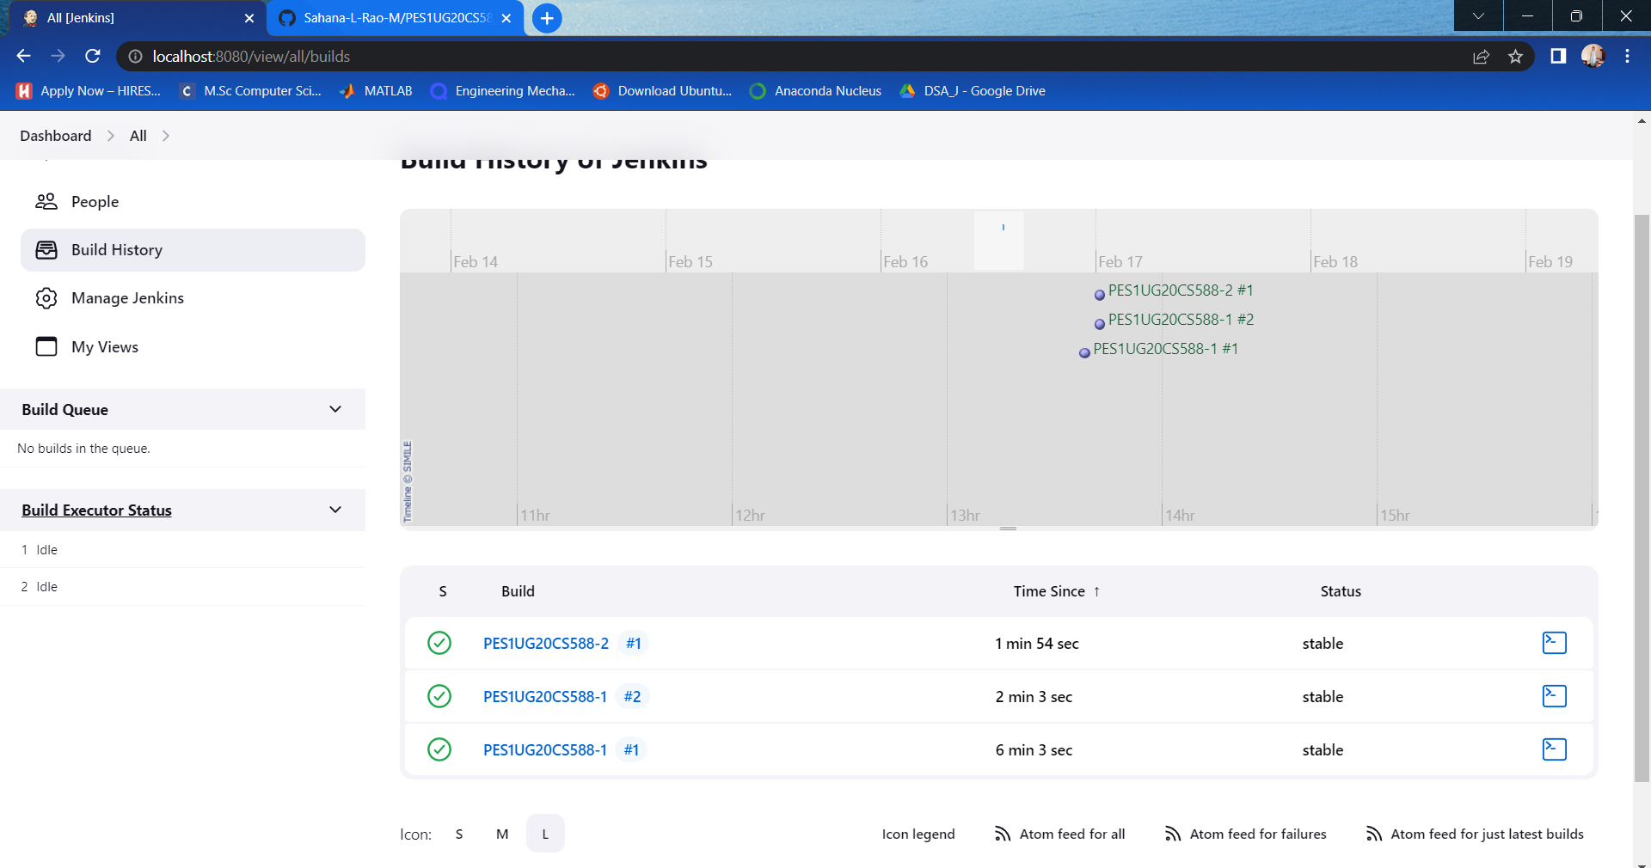

4)Jenkins Dashboard

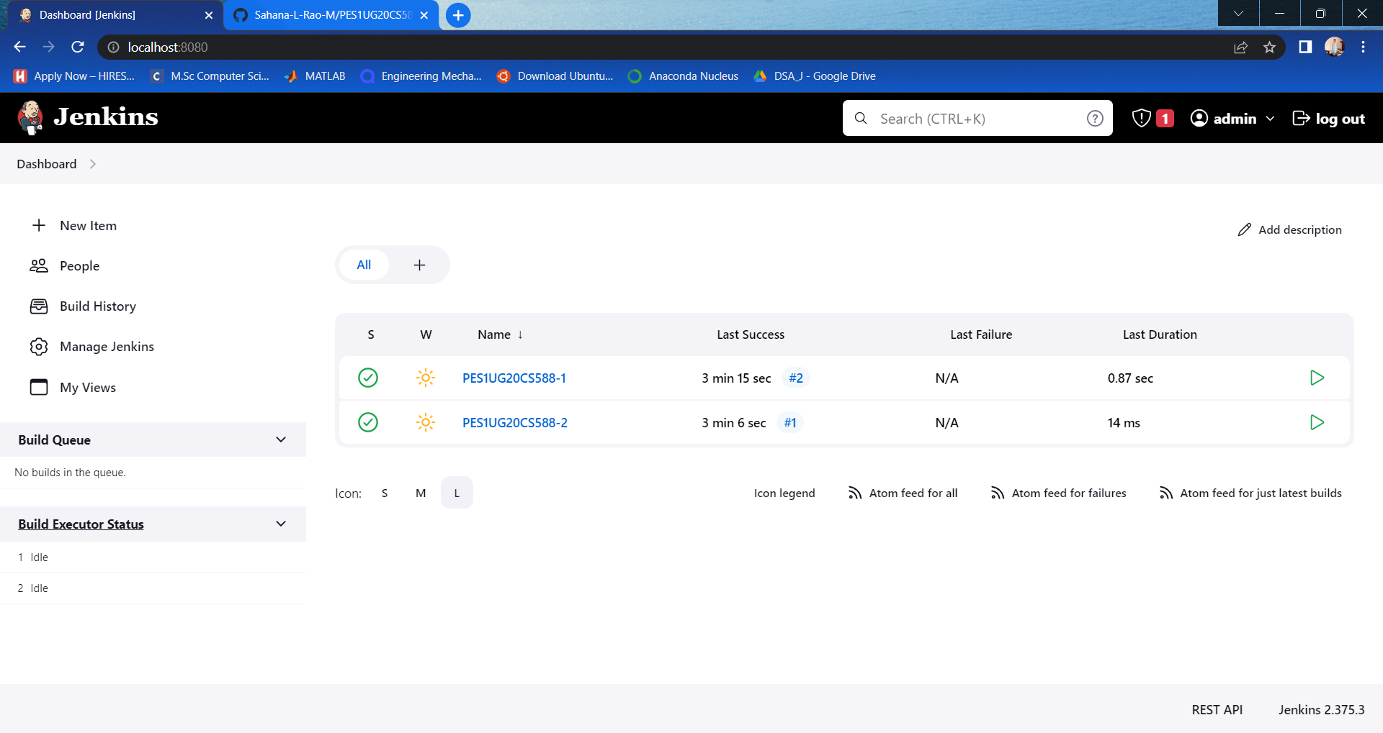

**TASK 4:**

1)Webhook added to GitHub Repositories

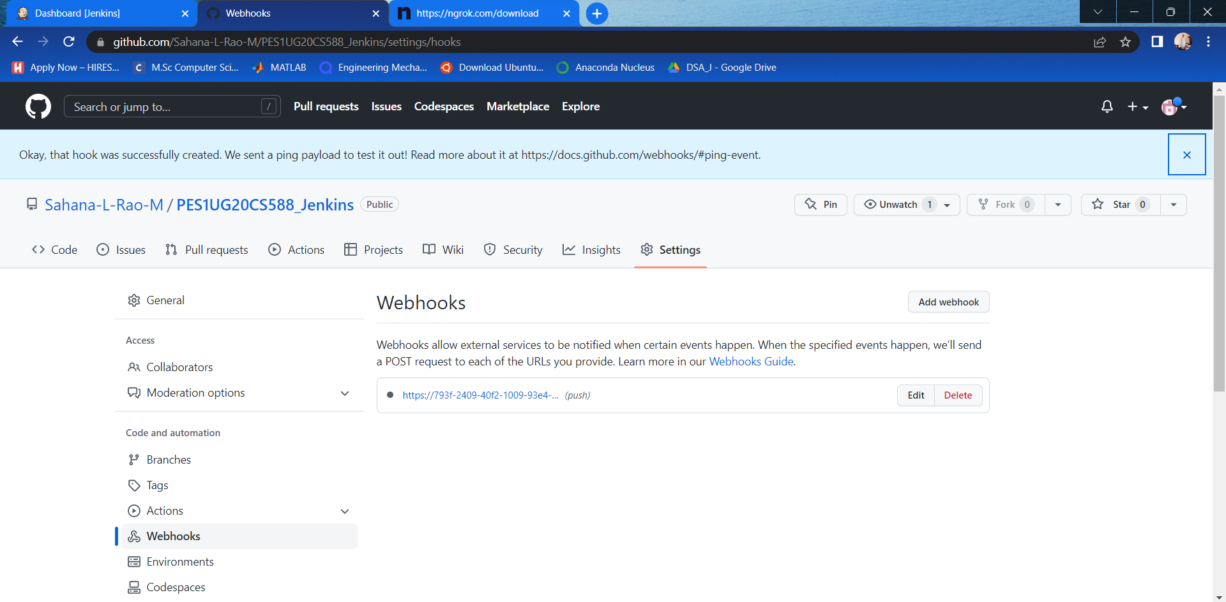

2)Console output of second job displaying change in hello.cpp:

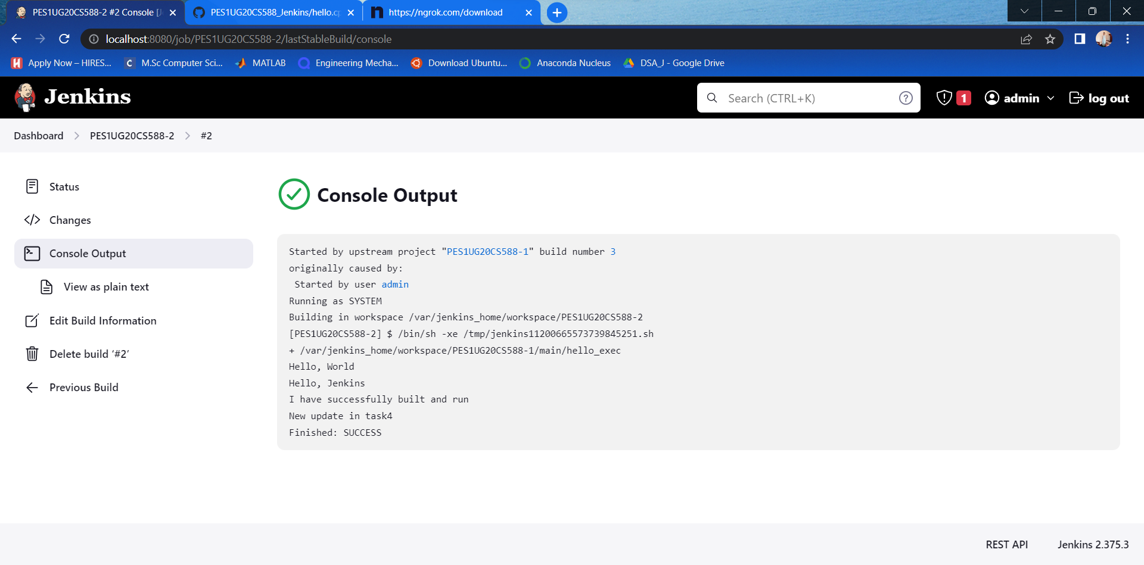

**Task 5:**

1)Code to create basic pipeline using GitHub repository:

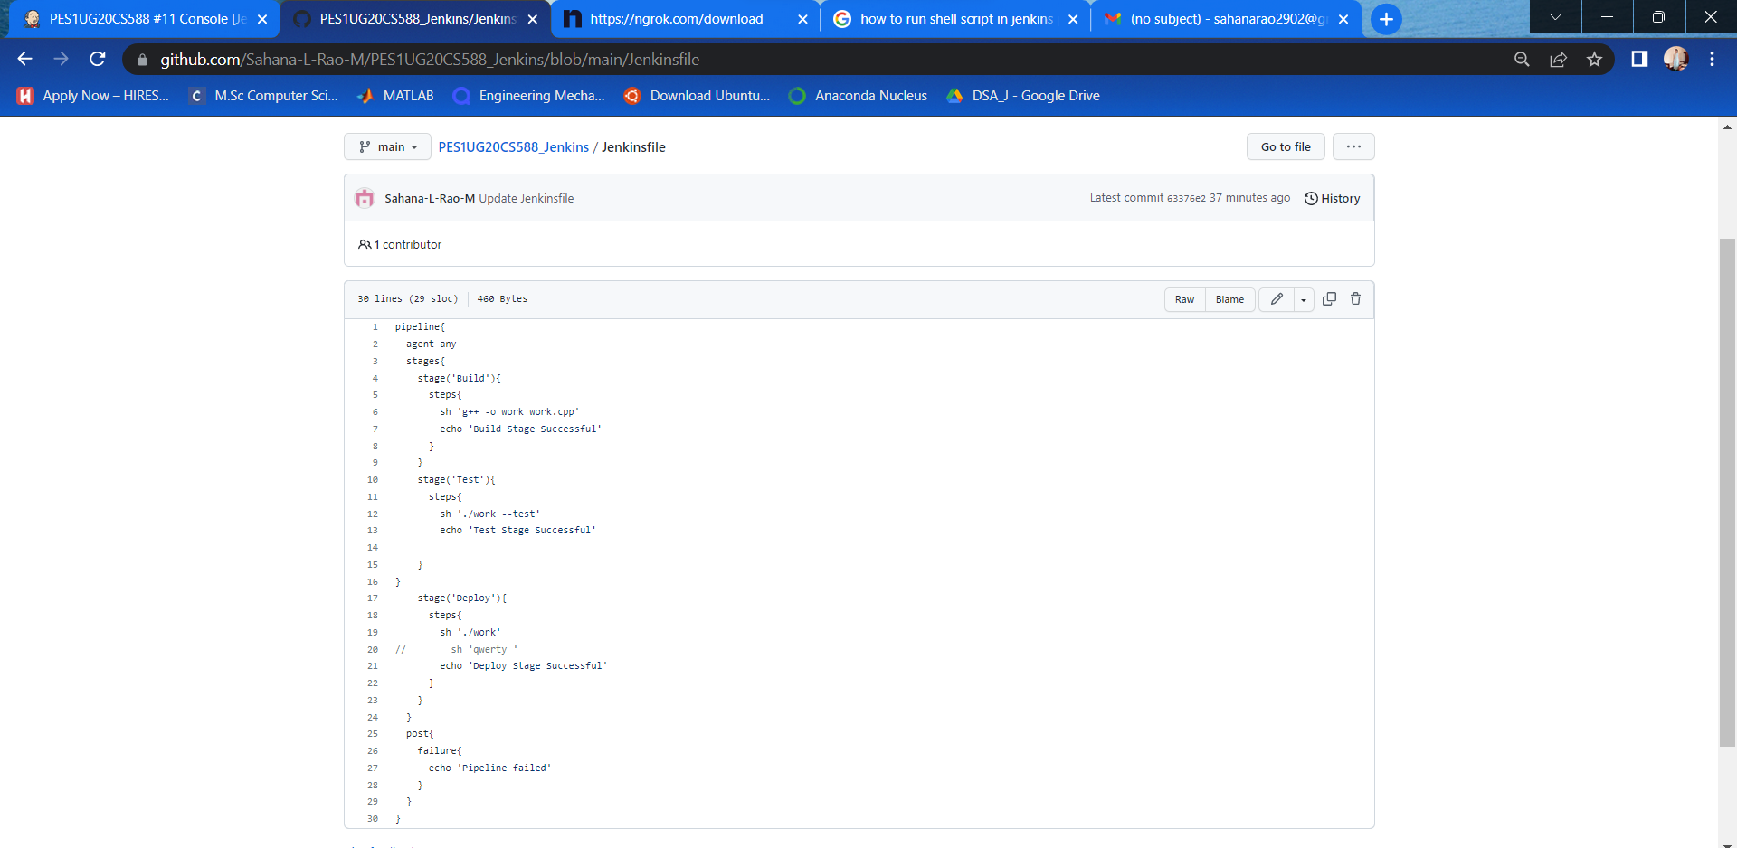

2)Output of working created pipeline:

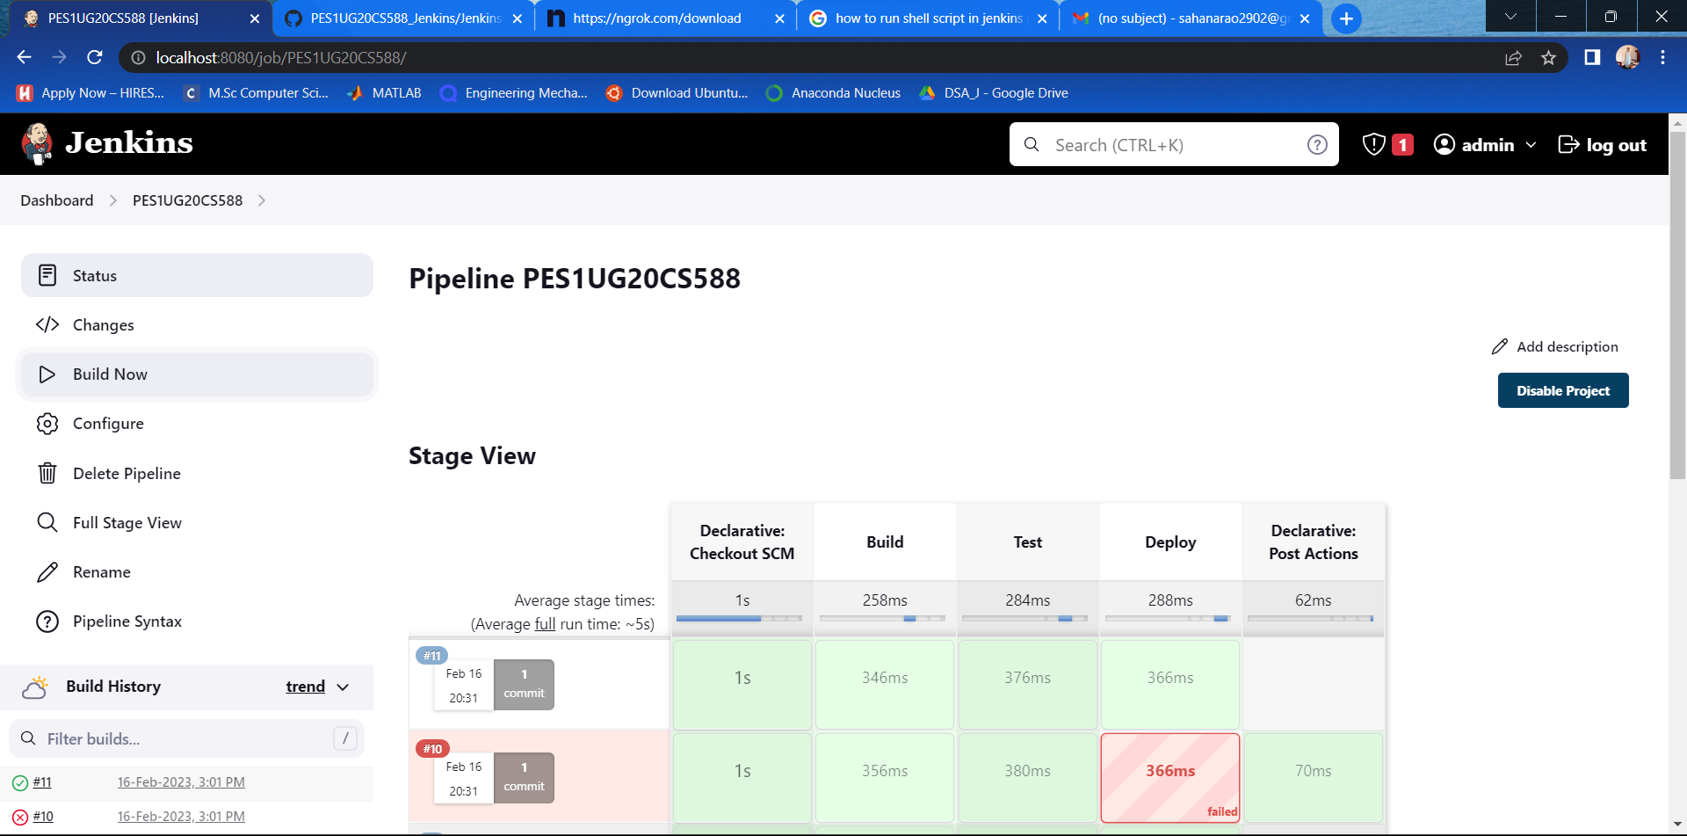

3)Console Output of the pipeline

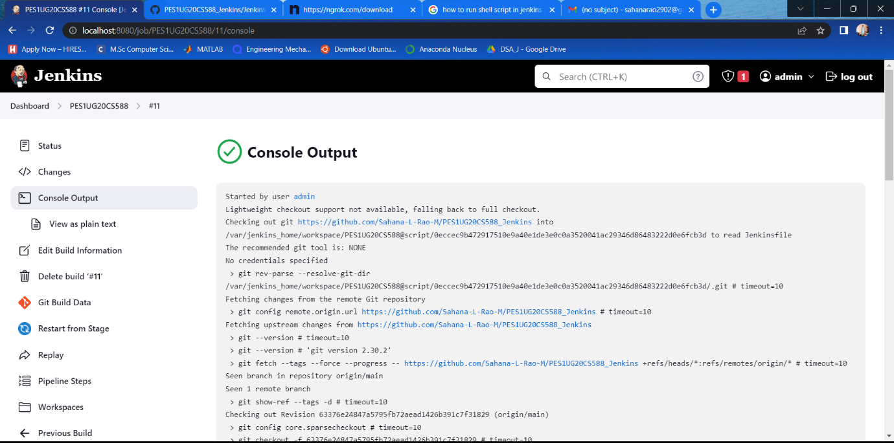

4)Link to the created Github Repository

<https://github.com/Sahana-L-Rao-M/PES1UG20CS588_Jenkins>